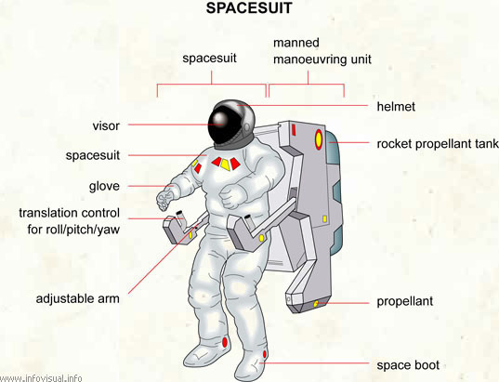

<https://infovisual.info/en/transport/spacesuit>

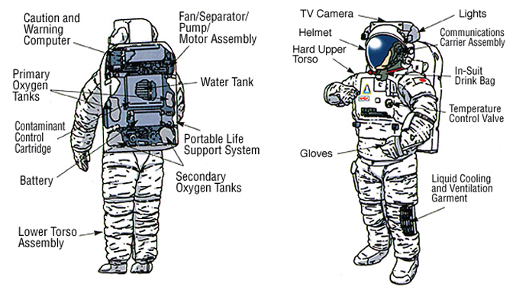

<https://kannada.yourstory.com/read/984865c76e/space-suit-to-protect-the-soldiers->